LAB 5 –

Container Virtualization for Windows

Name: Zamir Lalji

Professor: Khalil Abuosba

Due date: March 23rd 2019

Student Number: 212779997

Part 1: Screenshots of each question that is needed:

q4-5:

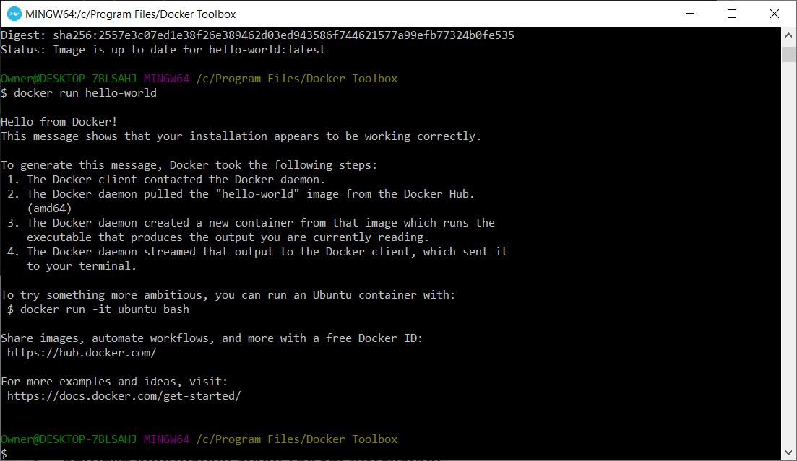

Q6:

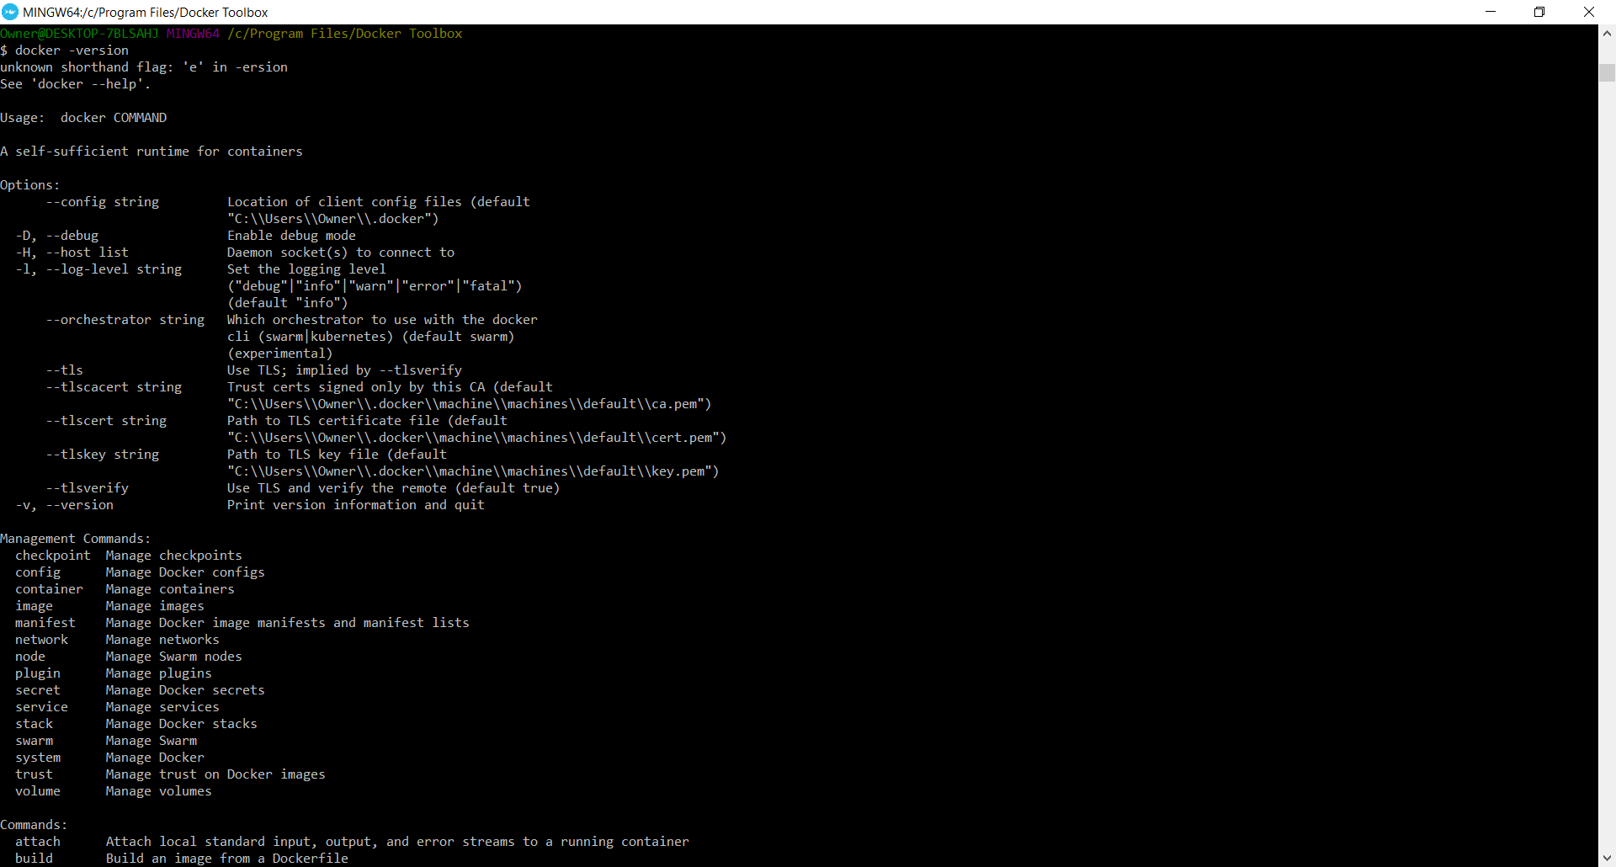

Q7: 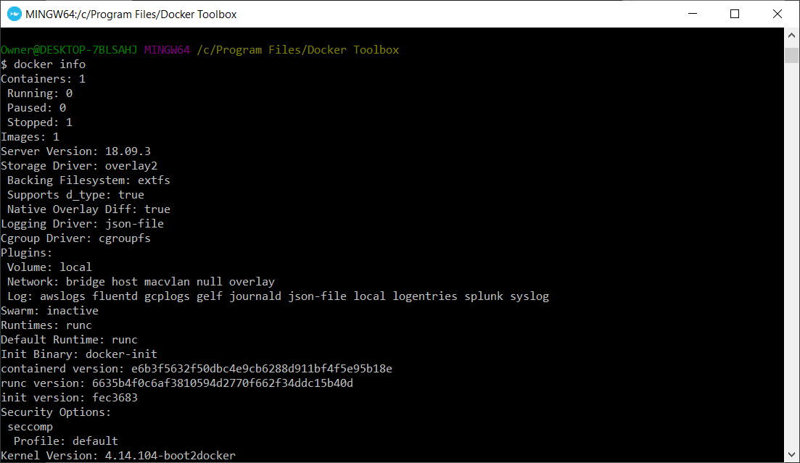

Q8: 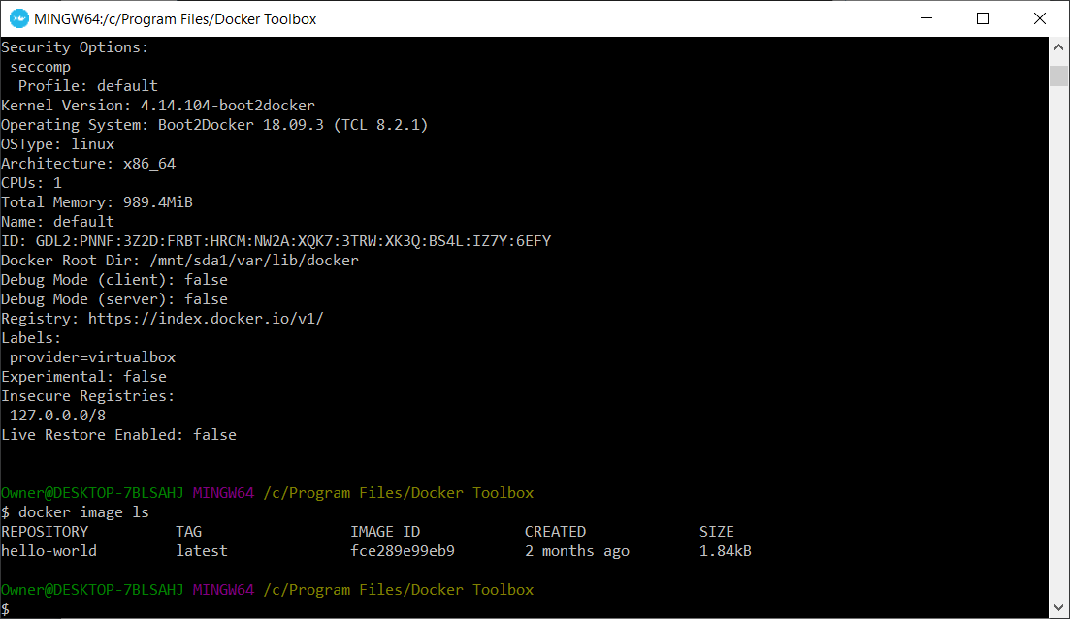

Q9:

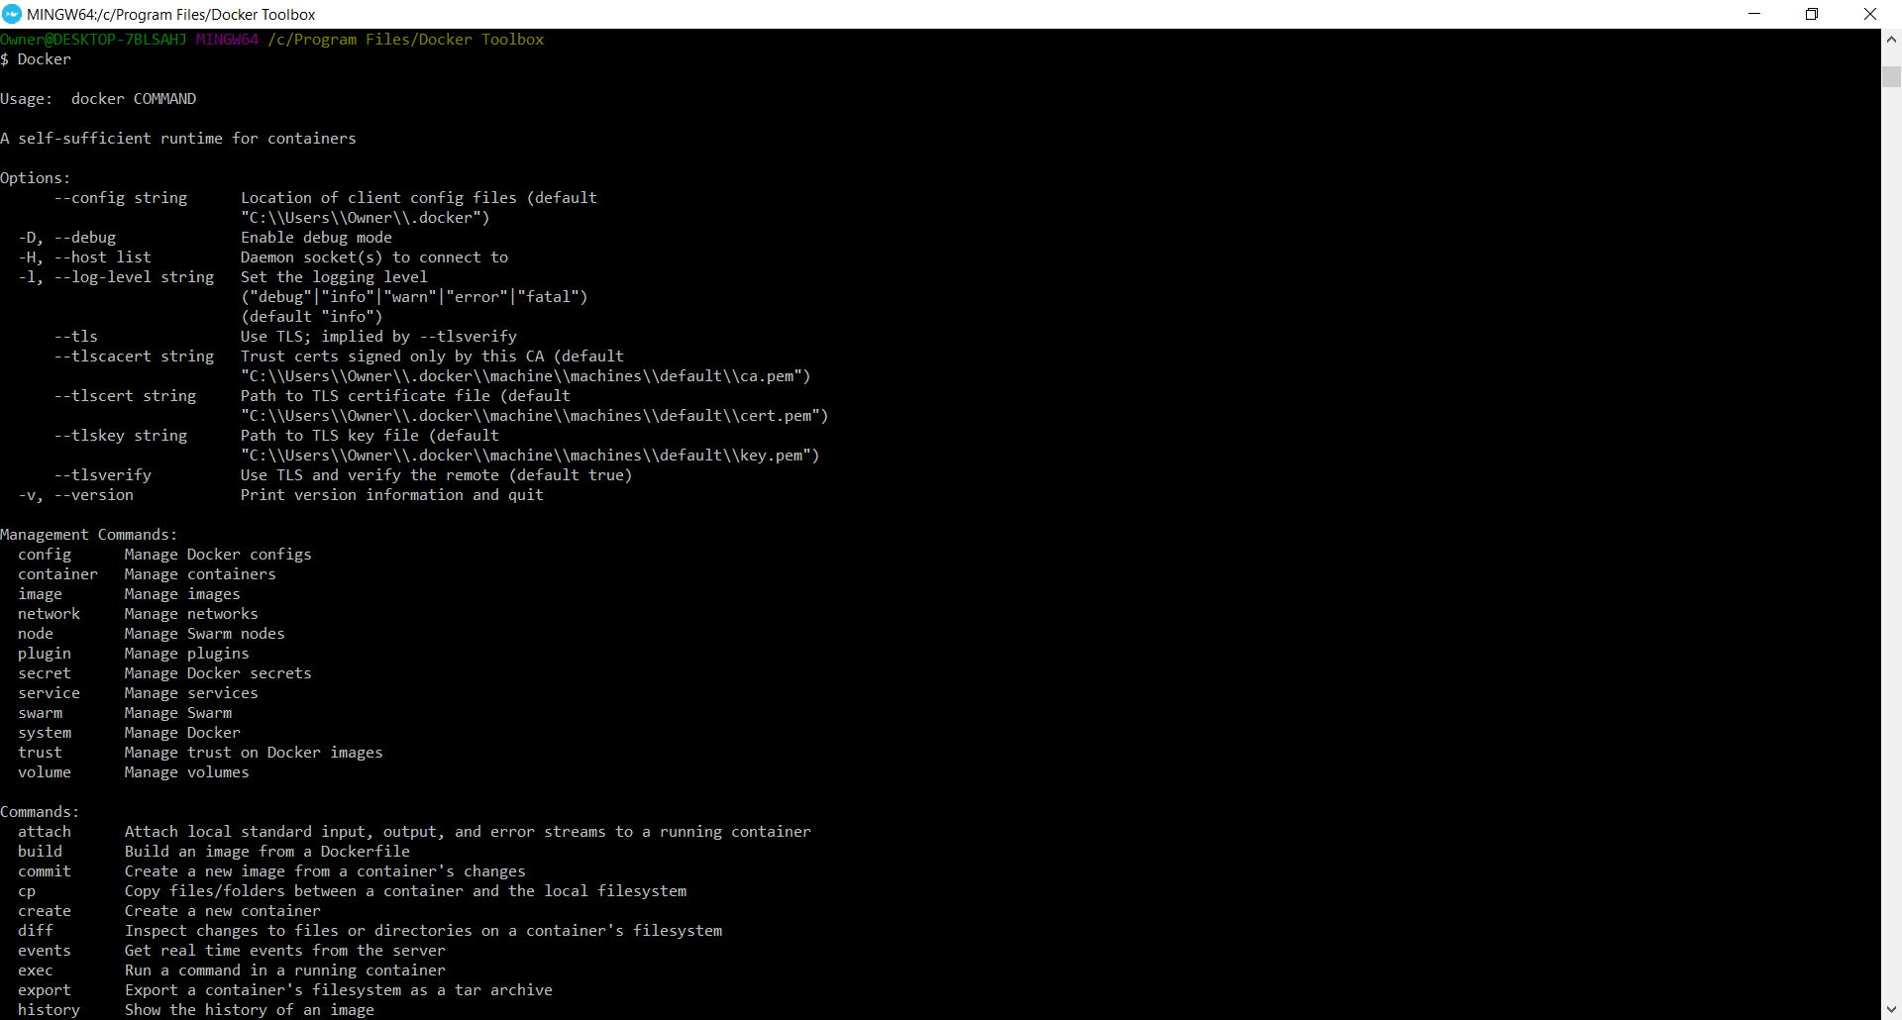

Part 2: Screenshots or question 1-6 for part 2

Q1-3:

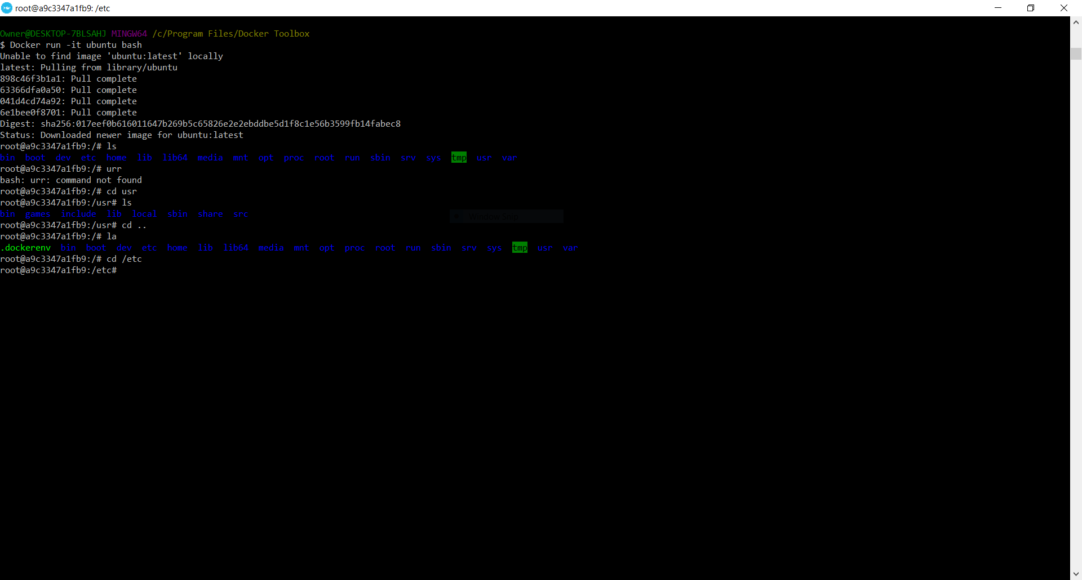

Q4: 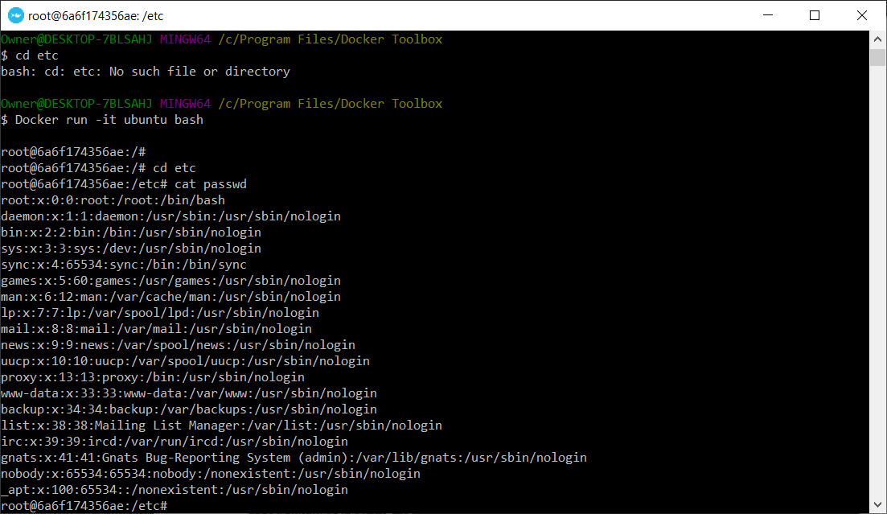

4a: No I do not see a password for the root account

4b: Since all usernames are followed by “X” this means that wherever “X” is it is supposed to represent where the password is supposed to be.

Q5: 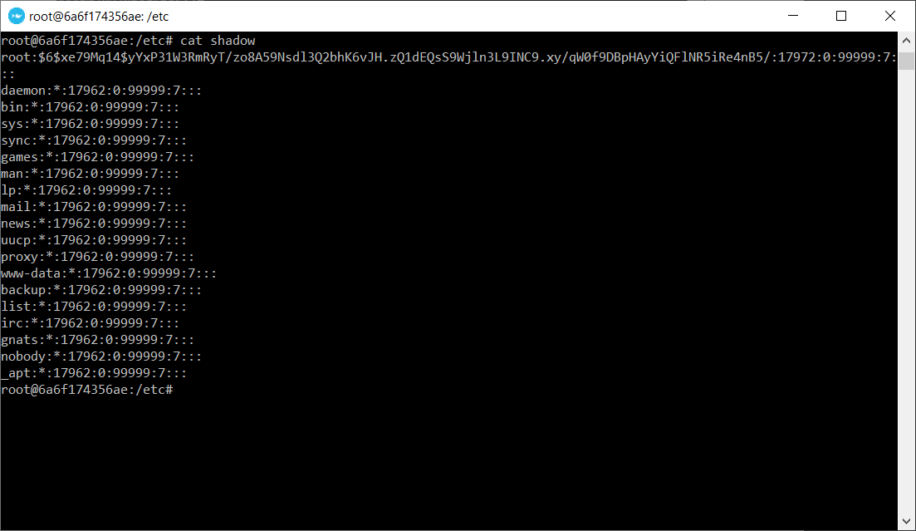

Q6: 1: $6$ represents the SHA-512 hash-function

Q6: 2: The salt value is going to be $6$xe79Mq14$